American Martyrs Catholic Community
welcomes families who wish to participate in the First Communion Liturgy

If you have a brother or sister who is a trained altar server, they are welcome to assist at the altar.

If you have a relative/friend who is a priest or deacon, he is also welcome to the table.

Please let us know:

Communicants Name________________

Mass Time (circle) 9am 11am 1pm

Priest/Deacon name___________________

Altar server name(s) _______________

________________

Please return this form to Patti Williams
Faith Enrichment Center
1701 Laurel Ave MB, CA 90266
310-546-4734 or fax 310-546-9104
pwilliams@americanmartyrs.org

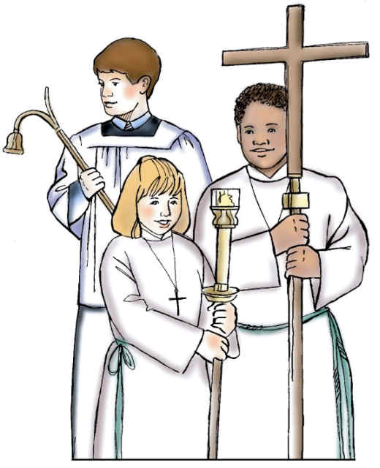

Preparing to Receive the Eucharist

- During the next few weeks prior to the special day, the best way to prepare your child is to bring him/her to Mass. The focus of the Sunday liturgy is the focus of our faith – receiving the Eucharist. The word communion means that we are united with Jesus Christ and one another.

- Whenever you are working on plans for the First Communion Day, take a minute to thank Jesus for coming to us. As important as the celebration is, try to talk about the fact that receiving Jesus is more important.

- As a sign of respect for Jesus, Catholics fast before receiving Holy Communion. This means that we do not eat or during anything for one hour before Communion time. Drinking water does not break our fast.

- When Communion time comes, the priest or Eucharistic minister holds the host up to each of us and says, “The Body of Christ.” We believe that Jesus is really present in Holy Communion. We say, “Amen.” Amen is a word that says “Yes, I believe.”

- You can choose to receive the host in your hand. To do this, you put your right hand under your left hand and hold both hands out, palms up, to receive the host. You then use your right hand to but the host in your mouth.

- After communion, Jesus is really present with us. We can tell Jesus whatever is in our hearts. We can say a prayer thanking Jesus for coming to us.

Here is an after-Communion prayer your child might memorize:

Stay with me, Jesus,
help me do what is right.
Stay with me, Jesus,
each day and night.
Thank you, Jesus, for coming to us.

Family Meal Blessing
Gather around your meal table, place your bread loaf in the center

Leader: In the Name of the Father, and of the Son, and of the Holy Spirit.

All: Amen

Child:

One day, Jesus and his friends wanted to go up into the mountains. Soon many people began to follow them. These people wanted to be with Jesus and listen to him. Jesus talked to them all day. By evening everyone was hungry.
“There is a young boy here,” Andrew told Jesus, “who has five loaves of bread and two dried fish. He is willing to share them.”
The boy gave his bread to Jesus. Jesus raised His hands in thanks to God. Then something wonderful happened. There became enough food to feed all five thousand people with 12 baskets of food left over.

Reader:

God is the giver of all good things. He lovingly provides for all our needs. That God may bless us with daily bread, we pray:

All: Father, we thank you.

Reader:
For those who are hungry, that we may share with them, we pray:

All: Father, we thank you.

Reader: For all those who help grow the food we now eat, we pray:

All: Father, we thank you.

(The leader and all those gathered extend their hands over the food)

Leader:
O Lord, bless this food, created by you, that it nourishes us in body and in spirit through Jesus our bread, our Lord and life. We ask this and all good things in His name.

All: AMEN.

